Software Design Document

NSW Traffic Penalty Data Analyser

Thomas Chapman s5251549

Table of Contents

1.0 System Vision 3

1.1 Problem Background 3

1.2 System Overview 3

1.3 Potential Benefits 3

2.0 Requirements 4

2.1 User Requirements 4

2.2 Software Requirements 4

2.3 Use Cases & Use Case Diagrams 5

3.0 Software Design and System Components 8

3.1 Software Design 8

3.2 System Components 9

3.2.1 Functions 9

3.2.2 Data Structures / Data Sources 9

3.2.3 Detailed Design 10

4.0 User Interface Design 11

4.1 Structural Design 11

4.2 Visual Design 12

References 13

# System Vision

## Problem Background

The NSW Penalty data acquired from Kaggle.com presents the data needed for this project. This data comes in a file that contains a large amount of information. In order to process this information, it is necessary that some sort of software that can automate this process is put in place. The NSW government has approximately 600 permanent roadside collection devices and all these devices are storing and collecting data every day of the year. This would generate an absurd amount of data for a person to try control/measure that is why automation of this process is needed.

## System Overview

The proposed solution is to give the users an interface that allows this large amount of data to be easily viewed through filters. Allowing the user to select specific categories they would like to see for example, how many car related offences or bike related offences. There are other possible uses for this data as well, such as filtering times and offences and using that information to work out what peak times offences take place on the roads. Using that idea, it would be important to have some sort of visual element weather that is graphical or some sort of way to display an image that relates or represents that data effectively.

## Potential Benefits

This project has a huge potential to be a tool that can be used for many different people. Could be used for day-to-day drivers working out what roads to avoid for traffic and cameras. Law enforcement or ambulances could use this software to work out best routes to travel to and from patients. There are a great range of potential opportunities to create an easy use of current methodologies. This representation of data can allow for improvements by government and those looking to make their businesses more efficient. It is important that the project provides benefit to a large array of people and this can be done through the proposed idea.

# Requirements

## User Requirements

The user will have access to this software through whatever device is present to them. The targeted audience will be business who don’t have a logistics department and can use this as assistance to help them expand and make for efficient deliveries, pickups etc. This software will show visual images of graphs or information about the selected areas they might be traveling in. Further uses could be those working on site can notify drivers of best routes or places to avoid through their communication methods. The main landing page will consist of options regarding what the user wants to search for, then once all the filters are in place a display of the information filtered will show.

## Software Requirements

R1.1 – The program shall have a landing page that presents a array of options to client.

R1.2 – The program shall have a menu/dropdown of options on relevant information the client may choose from.

R1.3 – The program shall take the selected menu options and apply the filters to enable a result/output.

R1.4 – The program should only display information once the user has confirmed that the filters have been selected, ensure a button is pressed labelled done etc.

R2.1 – The program shall be able to read data and information from a spread sheet.

R2.2 – The program will retrieve information from a .csv file from kaggle.com, source listed here:

<https://www.kaggle.com/datasets/llihan/australia-nsw-traffic-penalty-data-20112017>

R2.3 – The program shall take use of a method of preforming formatting of the document so python can interpret the information easier, this will be done using PANADS.

R2.4 – The program will need to include a database this will be done by using mySQL and ensuring that all data is presented correctly is imperative

R2.5 – The program must be configured carefully and made that so no form of external editing or SQL injection takes place as this would be the program at risk of failure.

R3.1 – The information will then be displayed in a manner that is readable and the view or presentation can be changed depending on the user preference.

R3.2 – To present this data a python library called Seaborn will be used to display relevant data to the user.

R3.3 – The program shall present the data filtered until the user closes or wants to return to the initial landing page.

## Use Cases & Use Case Diagrams

An example use case scenario will be a user wants to display where all digital speed / red light cameras are located. To reduce the number of results they are asked to select a location area, this is done using a location code. This information would be displayed in a table/list. The user in this scenario wouldn’t have an option to choose how the information is displayed as a graph would not be suitable for this purpose. This result will display the location of the camera and give the location details in the form of an address.

It is assumed whatever device the user is using is logged in or connected already.

USE CASE 1:

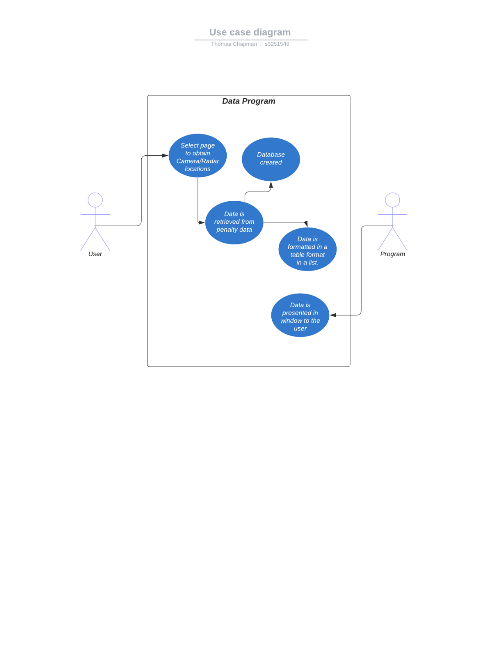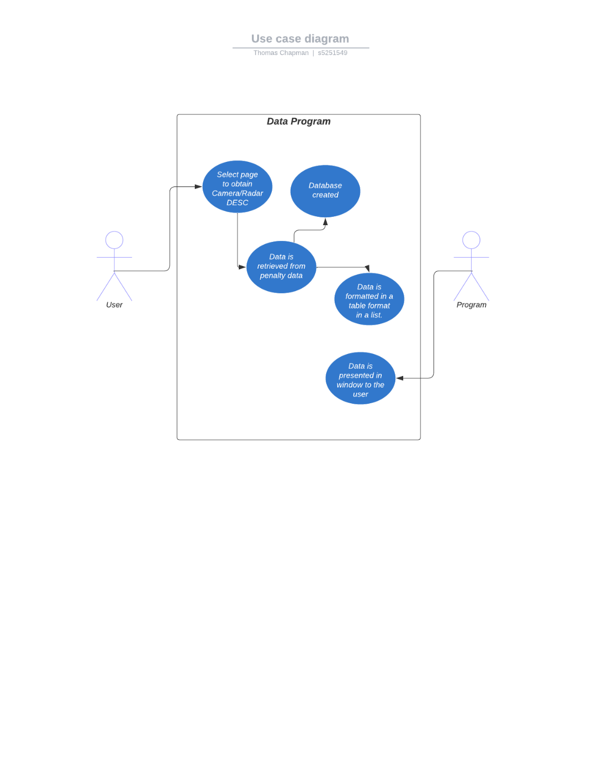

Use case 3 will allow the user to select the camera type and the offence desc it relates to. This will be present on the page with images and graphs.

Use case 2: Is a very straight forward page where the user will select the page and it will present all camera locations and their location in the form of a table (list) format.

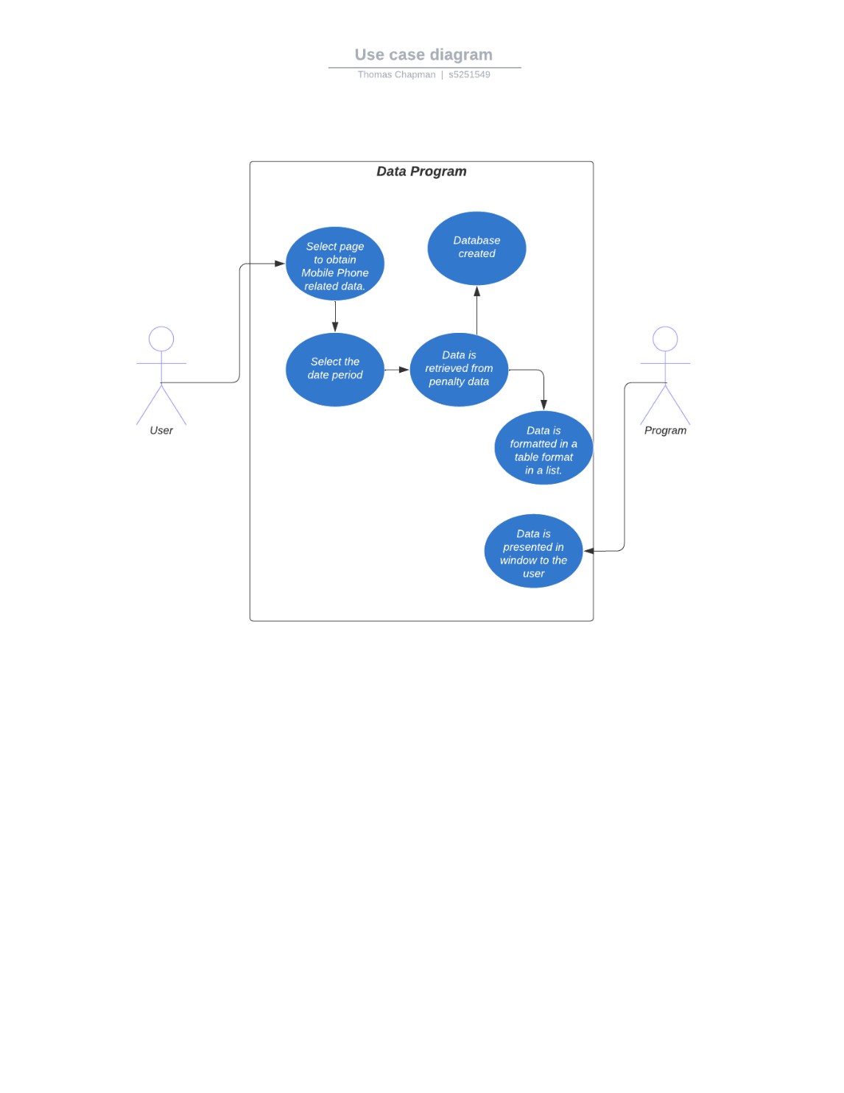

Use Case 4 will be where the user selects the mobile phone related data page. This is where the user will be able to see mobile phone related incidents during a period of time selected by the user.

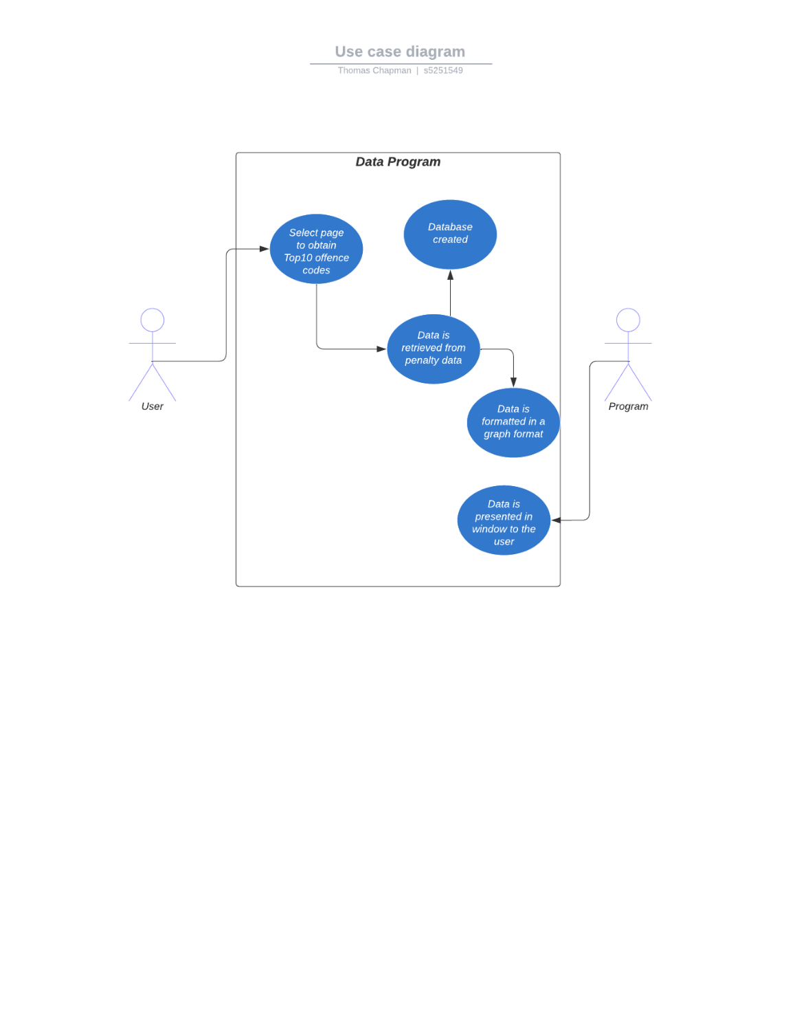

Use case 5 is a page where the top 10 OFFENCE_CODE values are displayed in the form of a graph of some sort.

# Software Design and System Components

## Software Design

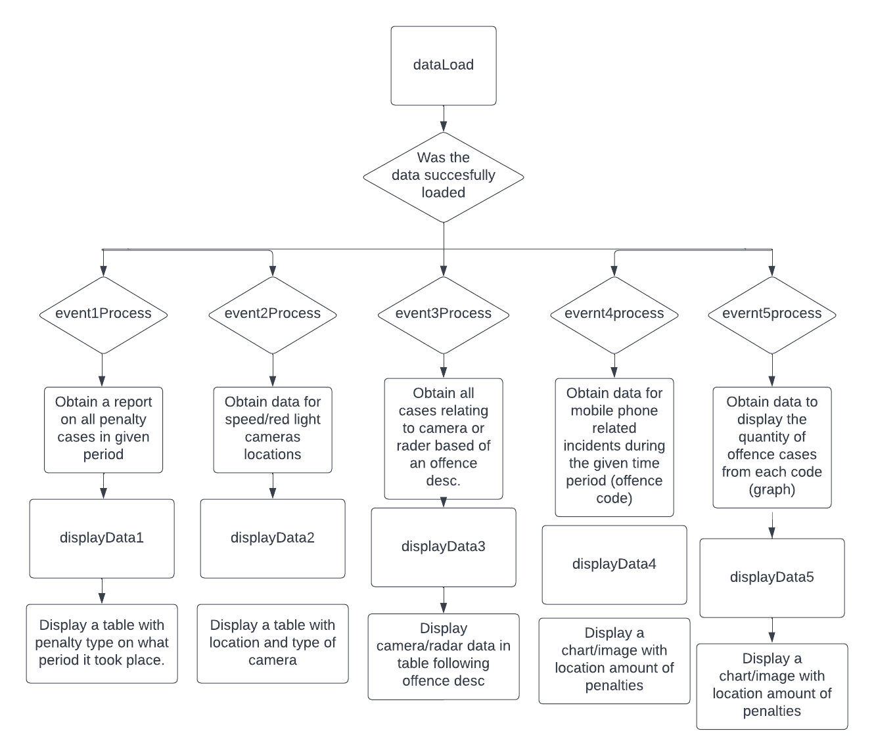

## System Components

### Functions

Function ‘loadData’:

This function’s role is to grab the data from the csv file and obtain the relevant lines of code in order to create the resulted information needed.

Function ‘displayData’:

This functions role is to produce an output from the data retrieved and present this to the user.

Function ‘eventNumberProcess’:

This functions job is a selection made by the user to display the requested information; all data required is easily sorted by the use of a filter/selection made by the user. All selections use date which is an int. ‘event3Process’ uses and offence code to retrieve mobile phone related incidents and ‘location’ is needed. This is presented on a graph whereas the others are represented on a table.

### Data Structures / Data Sources

The program will contain the use of an external data source which is the penalty data. This data will be presented through the use of primarily list structures and some arrays. There will need to be lists for each of the primary 5 pages. Each page contains different values, and this means different data will need to be withdrawn from the csv file and presented. The following are the values that will be used to present data.

OFFENCE_CODE, OFFENCE_MONTH, OFFENCE_DESC, LOCATION_DETAILS, CAMERA_TYPE, CAMERA_IND

Each of these values hold different values, int, date and string they all need to be implemented into the system.

Event1:

Event1 needs to use the values of OFFENCE_MONTH, OFFENCE_CODE, OFFENCE_DESC. These allow event1 to represent a filtered display of the dates selected on the page. OFFENCE_MONTH is relevant to the date filtered. OFFENCE_CODE obtains the quantity of penalties relating directly to that. OFFENCE_DESC displays next to the totals made from the OFFENCE_CODE

Event2:

Event2 needs to use the values of LOCATION_DETAILS, CAMERA_TYPE. LOCATION_DETAILS is used to show the address of CAMERA_TYPE in a table format.

Event3:

Event3 needs to use OFFENCE_CODE, CAMERA_IND and OFFENCE_DESC. OFFENCE_CODE shows all incidents if CAMERA_IND is true. Then next to the OFFENCE_CODE, OFFENCE_DESC is present in a form of a table.

Event4:

Event 4 needs to use OFFENCE_MONTH, OFFENCE_CODE, OFFENCE_DESC. OFFENCE_MONTH will allow a filtered selection and enable a table that shows data from that time period. OFFENCE_CODE is what we will use to obtain the information for the mobile related incidents. OFFENCE_DESC will be presented in the table to show what the result was.

Event5:

Event5 needs to use OFFENCE_CODE, OFFENCE_DESC, there will be a limit to how many results are displayed. It will only obtain the largest 10 quantities of OFFENCE_CODE values. This is because there are far too many to plot on a graph or table.

### Detailed Design

Pseudocode for all non-standard / non-trivial algorithms that operate on data structures

# User Interface Design

This section of the user interface design was generated with tools such as lucid chart and wireframe makers. The following designs. The structural design is a representation of the basic function of the program. It shows how the program follows through different selections and commands. Ideally the programs final product will take on this form however change may occur if better alternatives present themselves. Each of the following images of proposed design will have a brief explanation on their features/functions.

## Structural Design

The navigation below is assumed that the user is already logged into their device and application. They will land on the ‘home’ page and be presented with a screen with a navigation and an image relevant to them program. From they’re the users have access to tools that allow them to edit the program within limits such as view and a help section to guide them on how to operate. The primary focus area is the data retrieval which takes place from the landing page. This page presents the users with a few options where they can select the filters of data, they wish to obtain information from. Once these selections are made the users choices will present the data they selected and will be displayed to them. The navigation is persistent with each stage of the navigation/pages therefore the user can return to the start with ease.

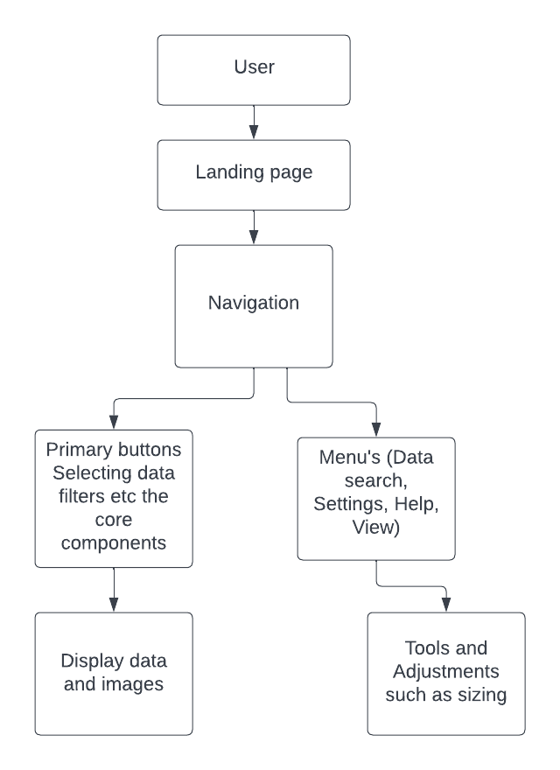It is important to make sure the user isn’t overwhelmed with information and the choices they can choose from are realistic and aren’t complicated. The user shouldn’t need training to operate the software all prompts and interactive boxes should provide enough guidance to help them achieve what they want. Users will have choices such as dates, locations, offences and a choice of different devices the data has collected. During construction of the software necessary changes will be made if any issues arise or extra input is needed.

## Visual Design

These designs show a rough idea as to what the home page and another page will look like the user will always land on the first option and then they will have to choose from. The navigation bar is on the right and provides 5 primary options to choose from which are the functions of the program. These will apply different options to the pages displayed and some require different selections to be made. The images displayed to the user depend on the page they are on, and the user has full control over the filters they wish to apply. The data will always be present in the middle of the screen and the navigation will highlight the current page that is active.

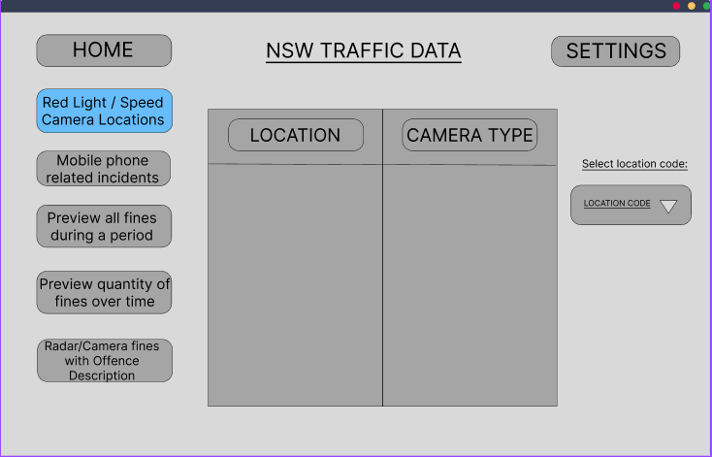

# References

Transport for NSW, N. S. W. (n.d.). *Average daily traffic volume*. Transport for NSW. <https://roads-waterways.transport.nsw.gov.au/about/corporate-publications/statistics/traffic-volumes/index.html>

*Australia NSW traffic penalty data 2011-2017*. (n.d.). Www.kaggle.com. Retrieved September 1, 2022, from <https://www.kaggle.com/datasets/llihan/australia-nsw-traffic-penalty-data-20112017>

‌